VENDING MACHINE
DESIGN INTRODUCTION
Vending machine is an automated machine which is intended to provide the users with a variety of items after cash, a credit card or other form of payments are inserted into the machine.The project involved designing a vending machine that could dispense four different products with varying prices and has the additional feature of returning change when a higher denomination coin was inserted. The vending machine only accepts coins of denominations five and ten.
The design of the vending machine was accomplished through the creation of a Finite State Machine (FSM) model, which defined the machine's different states, inputs, and outputs, as well as the transitions between the states. The FSM model was implemented using Verilog code, which defined the different states and their corresponding logic for accepting coins, dispensing products, and returning change.

BLOCK DIAGRAM
Figure 1 shows the block diagram of vending machine. The Vending Machine takes in two different coins of worth 5 and 10 respectively and in turn increases the state accordingly. The machine dispenses out the item selected once its state is reached. It even gives out change if higher state is achieved.
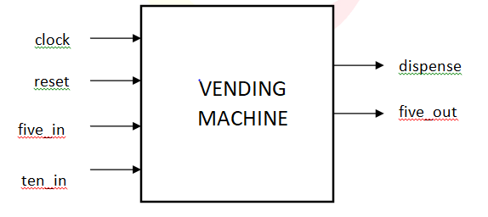
Item[3:0]
Figure1: Vending Machine
I/O Specifications
- Inputs: item[3:0], five_in, ten_in, clock, reset.
- Outputs: five_out, dispense.
- Other Variables: current_state, next_state
Description
- items: Indicates which of the four items is selected.
- five_in: Indicates whether the user has inserted a coin five or not.
- ten_in: Indicates whether the user has inserted a coin ten or not.
- five_out: Indicates whether a coin five is given out as change or not.
- dispense: Indicates whether the item is ready to be dispensed or not.
- current_state: Stores the current state of the FSM.
- next_state: Stores the next state to be achieved by the FSM.

WORKING OPERATION
The project consists of a vending machine. There are 4 items and 2 coins one of value 5 and second of value 10. First item of value 15, Second item of value 25, Third Item of value 35 and fourth item of value 45.To operate the vending machine, the user first selects the item they wish to purchase. The machine then sets the values for five_in and ten_in to 0. The user can then insert either 1 five or 1 ten coin per clock cycle into the machine. The vending machine will not dispense the item until the required amount for the selected item is collected. Once enough money is collected, the machine will dispense the chosen item along with any change that is owed, and the cycle will continue.

